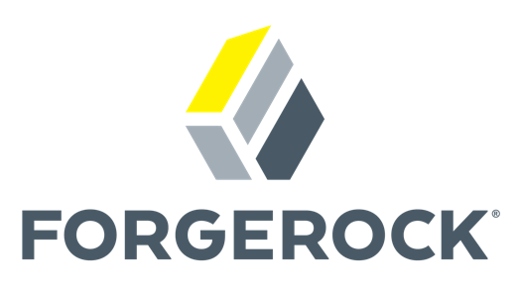


Proof of Concept Outline

Disclaimer of Liability
While every effort will be made to ensure that the information contained within the document is accurate and up to date, ForgeRock makes no warranty, representation or undertaking whether expressed or implied, nor does it assume any legal liability, whether direct or indirect, or responsibility for the accuracy, completeness, or usefulness of any information.
Further analysis on the detailed requirements, fine-tuning and validation of the proposed architecture is still required by the selected Systems Integrator and/or Architects in charge of architecting the IAM project.
Copyright Unless otherwise stated, copyright of all material published within this website is reserved by ForgeRock. All rights are reserved. As permitted under the provisions of the Copyright Act 1968, no part may be reproduced or re-used for any purposes whatsoever without the prior written permission of ForgeRock.

1 Introduction 5
1.1 Participants 5
1.1.1 Customer Team 5
1.1.2 ForgeRock Team 5
1.2 Logistics 6
1.3 Verizon Goal 6
1.4 Project Background 6
1.5 Proof of Concept Goals 6
1.6 Proof of Concept Assumptions 7
1.7 Proof of Concept Pre-requisites 7
1.8 Pre-check List 8
1.9 Environment Preparation 8
1.9.1 Operating System 9
1.9.2 Hardware Requirements 9
1.9.3 Java Requirements 9
1.9.4 Web Application Container Requirements 9
1.9.5 Architecture Topology 9
1.9.6 Integrated Systems 9
1.10 Proof of Concept Outcome 11
2 Evaluation 12
2.1 Success Criteria 12
2.2 Use Case Details 13
2.2.1 Use Case 1. – Using New FR Agent to Protect Customer Care App (CCA), POS, and Test Portal (SPA) 13
2.2.1.1 Prerequisite 13
2.2.1.2 Activity Diagram 14
2.2.1.3 Description 14
2.2.1.4 Success Criteria 15
2.2.2 Use Case 2. – Using FR Identity Gateway to Protect CCA, POS, and Test Portal 15
2.2.2.1 Prerequisite 15
2.2.2.2 Activity Diagram 16
2.2.2.3 Description 16
2.2.2.4 Success Criteria 17
2.2.3 Use Case 3. – SAML (Salesforce) 17
2.2.3.1 Prerequisite 17
2.2.3.2 Activity Diagram 17
2.2.3.3 Description 17
2.2.3.4 Success Criteria 18
2.2.4 Use Case 4. – OIDC (Salesforce) restricted Access by IP only 18
2.2.4.1 Prerequisite 18
2.2.4.2 Activity Diagram 18
2.2.4.3 Description 18
2.2.4.4 Success Criteria 19
2.2.5 Use Case 5. – Test CA PA migration to ForgeRock Web Agent 19
2.2.5.1 Prerequisite 19
2.2.5.2 Activity Diagram 19
2.2.5.3 Description 19
2.2.5.4 Success Criteria 20
2.2.6 Use Case 6. – CA PA in front of CCA – to route through ForgeRock Identity Gateway 20
2.2.6.1 Prerequisite 20
2.2.6.2 Activity Diagram 20
2.2.6.3 Description 20
2.2.6.4 Success Criteria 21
2.2.7 Use Case 7. – Generic and Branded Login Screen Plus Duo MFA Integration 21
2.2.7.1 Prerequisite 21
2.2.7.2 Activity Diagram 21
2.2.7.3 Description 21
2.2.7.4 Success Criteria 22
2.2.8 Use Case 8. – Impersonation 22
2.2.8.1 Prerequisite 22
2.2.8.2 Activity Diagram 22
2.2.8.3 Description 22
2.2.8.4 Success Criteria 23
2.2.9 Use Case 9. – Certificate Authentication 23
2.2.9.1 Prerequisite 23
2.2.9.2 Activity Diagram 23
2.2.9.3 Description 23
2.2.9.4 Success Criteria 23
2.2.10 Use Case 10. – IWA Authentication 23
2.2.10.1 Prerequisite 23
2.2.10.2 Activity Diagram 24
2.2.10.3 Description 24
2.2.10.4 Success Criteria 24
2.2.11 Use Case 11. – External Federation (Multi-IdP) & ForgeRock to SiteMinder SSO 24
2.2.11.1 Prerequisite 24
2.2.11.2 Activity Diagram 25
2.2.11.3 Description 25
2.2.11.4 Success Criteria 25
2.2.12 Use Case 12. – SiteMinder to ForgeRock SSO 25
2.2.12.1 Prerequisite 25
2.2.12.2 Activity Diagram 26
2.2.12.3 Description 26
2.2.12.4 Success Criteria 26
2.2.13 Use Case 13. – ForgeRock Identity Gateway & Web Agent Integration 26
2.2.13.1 Prerequisite 26
2.2.13.2 Activity Diagram 26
2.2.13.3 Description 26
2.2.13.4 Success Criteria 27
2.2.14 Use Case 14. – Single Logout 27
2.2.14.1 Prerequisite 27
2.2.14.2 Activity Diagram 27
2.2.14.3 Description 27
2.2.14.4 Success Criteria 27
2.2.15 Use Case 15. – Internal Users never leaves Verizon Network for Auth-n/z 27
2.2.15.1 Prerequisite 27
2.2.15.2 Activity Diagram 28
2.2.15.3 Description 28
2.2.15.4 Success Criteria 28
2.2.16 Use Case 16. – Multiple Authentication 28
2.2.16.1 Prerequisite 28
2.2.16.2 Activity Diagram 29
2.2.16.3 Description 29
2.2.16.4 Success Criteria 29
2.2.17 Use Case 17. – Use LDS (Virtual Directory) for Auth-n/z 29
2.2.17.1 Prerequisite 29
2.2.17.2 Activity Diagram 30
2.2.17.3 Description 30
2.2.17.4 Success Criteria 30

Introduction

This document outlines the objectives for the Proof of Concept (PoC) to be conducted jointly by ForgeRock and Verizon in addressing their internal requirements.

As the name implies, we understand a “proof of concept” to be a quick exercise to demonstrate the features and functionality of ForgeRock products, such that you will gain confidence that we can meet the requirements. It is expected that the PoC will provide sufficient information for Verizon to make a decision on using ForgeRock products for your ODA project.

Included in the sections that follow are a short summary of your broader program objectives and how a consolidated identity strategy supports these aims, followed by a suggested outline for a PoC that demonstrates our capabilities in this area.

We will demonstrate your use cases in a PoC environment of your choice. You are welcome to watch us to install, configure and implement the use cases and ask us questions during the PoC. If we deploy the PoC into your environment, assuming it is aligned with our hardware and software requirements, once the PoC concludes, the environment should be destroyed unless agreed upon before the PoC.

Non-functional requirements (for example, performance benchmarks, high availability testing and integration) require extended testing time and are most often appropriate for a pilot. A pilot is typically conducted as a for-fee professional services engagement, usually with one of our preferred implementation partners.

Participants

Customer Team
Name | Role | eMail
Chandra Rane | Technical Lead | chandrashekhar.rane@verizonwireless.com
Ken Cerda | Project Oversight | ken.cerda@verizonwireless.com
Gary Francis | Executive Sponsor | Gary Francis@verizonwireless.com

ForgeRock Team
Name | Role | eMail
Justin Chin | Solution Architect | justin.chin@forgerock.com
Keith Daly | Technical Lead | keith.daly@forgerock.com
Mark Crean | Account Manager | mark.crean@forgerock.com
Arthur Sambar | Executive Sponsor | arthur.sambar@forgerock.com
Pete Angstadt | Executive Sponsor | pete.angstadt@forgerock.com

Logistics
PoC Delivery Location | Remote for install and configuration. Result presentation onsite.
Start Date | TBD
End Date | TBD
Hosting Environment | TBD

Verizon Goal
Verizon is looking to expand its IAM solutions based on the principles of standardizing and centralizing its IAM services across business units wherever possible. This will allow users to seamlessly and securely access resources across business units with a system that provides transparent, proactive and responsive security services. The goal is to integrate the IAM service with our Zero-Trust initiative and improve the user experience.

The Verizon internal project designator is: Next Generation Authentication (NGAUTH)

Project Background
The Verizon Enterprise IAM solution guiding principles include:

- IAM services will be delivered centrally to individual business units
- IAM services will be offered to business units through a standard set of services
- Business units will be able to seamlessly access resources across business lines
- The IAM architecture will support the Zero Trust Framework
- The IAM services will provide services to on-premise and cloud-based systems
- There will be a unified solution for authentication, authorization and auditing user accounts
- There will be common access policies for ABAC and RBAC
- Adaptive access decisions will be made in real time
- There will be a consistent and streamlined workflow for both privileged and non-privileged user accounts

Proof of Concept Goals
- The goal of the POC is to prove the ability of the ForgeRock Platform to deliver identity services that can be leveraged by different lines of businesses.
- It is not the goal of the POC to demonstrate integrations that mimic production, but rather a proof of functionality.
- A successful POC will enable Verizon to decide to move forward with ForgeRock as the preferred solution for user access and management.

Proof of Concept Assumptions
The following assumptions have been made in defining the scope of this POC:

- Sample data - Where sample data is needed, Verizon will provide sample data sets which will be masked and not contain confidential or Personally Identifiable Information (PII).
- System integrations - Integration with Verizon components will be performed with non-production systems - there will be no connections from the ForgeRock POC environment and production Verizon systems.
- Timescales - The POC is a time-boxed exercise, lasting 90 days from kick off on, TBD.

Proof of Concept Pre-requisites
To ensure a successful POC, the following requirements must be met prior to the start of the POC:
- Use cases, success criteria and a plan/timeline are agreed upon by ForgeRock and Verizon. Use cases are described in section four of this document.
- A business level sponsor has been identified for the POC and convenes a POC ‘delivery committee’ to validate the goals and plan for the POC.
- An Verizon provided project manager (or appropriate person acting in that capacity) is assigned to the POC. The role of the PM is to ensure that required resources are assigned to assist with the POC and to ensure timely resolution to any issues that may arise
- All components required in lab must be resolvable through FQDNS, not just host alias or IP addresses. All required ports must be pre-tested to ensure firewalls are not blocking. DNS and firewall configuration are readily available to the lab without needing to wait on request tickets or non-lab personnel.
- Access to key resources must be secured for the POC. For example, if integration with Microsoft SQL Server is required, a Microsoft SQL Administrator with the appropriate privileges and knowledge must be available in a timely manner. This POC requires subject matter expertise (SMEs) at the ready.
- All PKI requirements are already in place prior to ForgeRock Solution Architect arrival, this includes but not limited to the HSM system and any protocols that need SSL for the lab. We assume non-SSL for lab purposes, but aware some components may require, in those cases the certificates and trust stores are in place and required certificates and keys are at the ready.
- Email server must be configured, tested and available in the lab for the purposes of delivering alerts, prior to ForgeRock arrival.
- The ForgeRock environment requirements, as documented in Appendix B, must be completed and validated via a web sharing meeting (for example WebEx or GoTo Meeting) prior to ForgeRock coming onsite. This is scheduled to happen on TBD.
- A non-production POC environment must be available for the use of the POC for the whole duration of the POC. This POC environment must be such that any changes to the environment will not impact Verizon’s business operations and that other user(s) of the POC environment will not prevent or negatively impact the execution of this POC. ForgeRock will not conduct a POC in a production environment and will not be responsible for systems, and/or their data, connected to the POC environment.

Pre-check List
Task | Description | Completion Date
Sign-off of POC Scope and Required Test Environment | A review of the requirements, success criteria, timelines, and test environment specifications required to achieve desired results.  To be completed 2-3 weeks prior to the POC start date.
Verification of Lab Configuration and additional needs | Technical team follow up call to answer any additional questions, verify the lab environment and confirm if any additional needs are necessary.  To be completed 1-2 weeks prior to the POC start date.
Pre-Onsite Check in | Project team to confirm start date, daily start time(s), customer and ForgeRock staffing for both onsite and remote, lab configuration, remote access  To be completed 2-3 days prior to POC start date.

Environment Preparation
Section 1.9 Environment Preparation contains pre-req details for the Proof of Concept. The following ForgeRock products will be used during this PoC:
- Access Management version 6.5.2.2
- Identity Management version 6.5.0.2
- Identity Gateway version 6.5.2
- Web Policy Agent version 5.6.2

Recommendations below are based on the product documentation. Please refer to the latest online documentation if a conflict in detail exist.

Operating System
- Windows 2012 R2
- Red Hat Enterprise Linux, Centos 6, 7
- Amazon Linux 2
- Amazon Linux 2017.09
- Amazon Linux 2018.03
- SuSE 12
- Ubuntu 14.04 LTS
- Ubuntu 16.04 LTS
- Ubuntu 18.04 LTS

Hardware Requirements
- AWS – t3a.large (In DMZ Network)
- AWS – t3a.large (On Internal Network)

Java Requirements
- Oracle JDK 8, 11
- OpenJDK 8, 11

Web Application Container Requirements
- Apache Tomcat 7, 8.5, 9

Architecture Topology
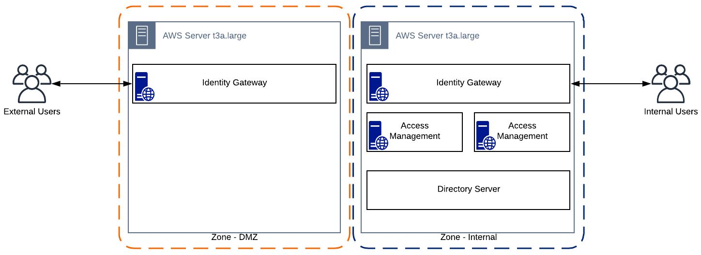

Integrated Systems
System | Details | Verification Date
CA PS | IP:  Host:  Port:  Uid:  Pwd:
Internal AD 1 | IP:  Host:  Port:  Uid:  Pwd:
Internal AD 2 | IP:  Host:  Port:  Uid:  Pwd:
Internal AD 3 | IP:  Host:  Port:  Uid:  Pwd:
External AD | IP:  Host:  Port:  Uid:  Pwd:
Okta | URL:  Uid:  Pwd:
Salesforce | URL:  Uid:  Pwd:
PeopleSoft | IP:  Host:  Port:  Uid:  Pwd:
Customer Care App (SPA) | IP:  Host:  Port:
LDS (Virtual Directory) | IP:  Host:  Port:
RSSX Web App | IP:  Host:  Port:
POS (SPA) | IP:  Host:  Port:

Proof of Concept Outcome
At the conclusion of the PoC, all of the agreed use cases will have been demonstrated successfully. A report that documents the activities undertaken and the means by which each use case was demonstrated will be presented to Verizon.

After agreement that the PoC has concluded, Verizon will remove any ForgeRock components deployed into their environment, and any temporary cloud resources (such as AWS instances) will be shut down.

Evaluation

Success Criteria
Number | Use Case | Description | PASS or FAIL
1. | Zone Management with FR Agent - Step Up Auth-n/z | Via FR Agents – the ability to traverse from Zone 1 to Zone 2 and vice versa with the appropriate auth-n/z checks and requirements applied
2. | Zone Management with FR IG - Step Up Auth-n/z | Via FR IG – the ability to traverse from Zone 1 to Zone 2 and vice versa with the appropriate auth-n/z checks and requirements applied
3. | SAML Integration | FR as IdP for Salesforce. Sending over a custom SAML assertion
4. | OIDC Integration | FR as IdP for Salesforce, restricting by IP Address (Internal users only able to access Salesforce). Sending over custom claims
5. | PA Migrate to FR Agent | Migrate from CA PA to FR Web Agent
6. | PA Migration to FR IG | Migrate from CA PA to FR IG
7. | Branded Login & 2FA | Provided Branded Login for Internal Verizon users and a generic login for external user. Additionally, require Duo 2FA for external users
8. | Impersonation | Provide administrators the ability to impersonate an end user for troubleshooting purposes
9. | Certificate Auth-n | Allow device certificate based auth-n/z
10. | IWA Auth-n | Allow IWA based auth-n/z from windows and MAC systems
11. | Multiple External IdP & FR to CA SSO | Use an external IdP for auth-n. Auth-z is checked in FR. Additionally, we are testing FR to CA SSO
12. | CA to FR SSO | Provide capability to go from an auth-n/z session on the CA side, to FR protected app without challenging for creds again
13. | FR IG and FR Web Agent Integration | Show FR IG and Web Agent seamless integration
14. | Single Logout | Provide one logout URL that handles logout from FR and CA
15. | Internal Users do not go external for Auth-n/z | Users on the internal network do not need to exit the Verizon network to Auth-n/z
16. | Multiple Auth-n/z (IWA, Cert, 2FA) | Require multiple Auth-n/z layers to access a particular app. IWA, Certificate and Duo.
17. | Use LDS (Virtual Dir) for Auth-n/z | Use the LDS Virtual Directory instead of the four AD Domains (3 internal, 1 external) for Auth-n/z

Use Case Details
The following sections describes the use cases that will be demonstrated during the PoC, and also a description of how they will be demonstrated. Use cases may be demonstrated in a number of ways, including:

- Demonstration of the ForgeRock software in a test environment
- A white board discussion
- Demonstration of the use case in an existing ForgeRock demo environment

Use Case 1. – Using New FR Agent to Protect Customer Care App (CCA), POS, and Test Portal (SPA)

Prerequisite
- Install ForgeRock Access Manager 6.5.x
- Install Web Agent 5.6 on Test Customer Care App (CCA)
- Install Web Agent 5.6 on POS
- Install Web Agent 5.6 on Test Portal
- Configure Auth Tree for Zone 1 Cookie
- Configure Auth Tree for Zone 2 Cookie
- Test Zone 1 and Zone Cookie without IG to CCA, POS and Test Portal (SPA)

Activity Diagram
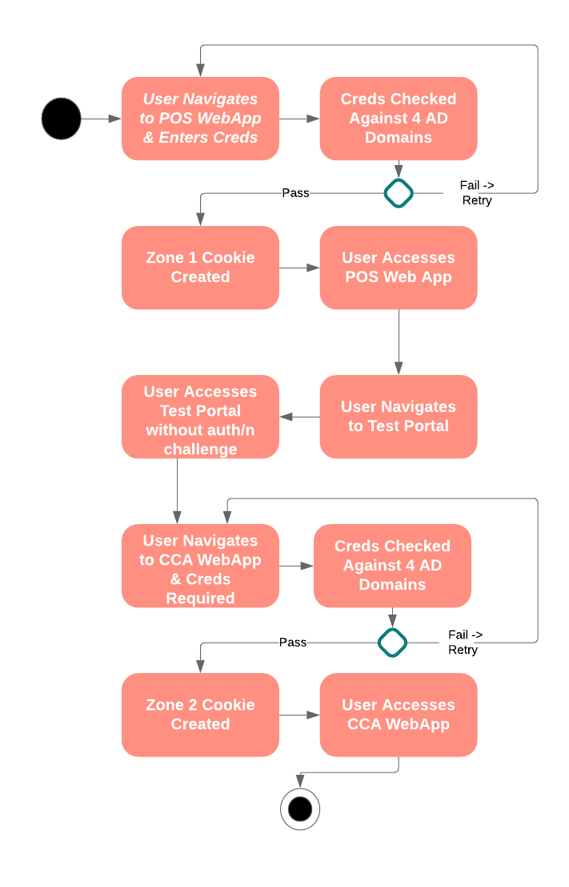

Description
- User navigates to the POS WebApp and is challenged for credentials.
- The user’s credentials are checked against the 3 Internal and 1 External AD Domains.
- If one of the Domains in Step 2 validates the users credentials proceed to Step 5
- If none of the Domains in Step 2 can validate the user’s credentials, fail login and return to Step 1 requesting users credentials with failed login message
- User accesses POS Web App with Step 12 headers
- User Navigates to Test Portal with Step 12 headers
- User can immediately access the Test Portal without Credential requested (Kerberos token generated)
- User navigates to CCA WebApp is required to enter credentials
- The user’s credentials are checked against the 3 Internal and 1 External AD Domains.
- If one of the Domains in Step 9 validates the users credentials proceed to Step12
- If none of the Domains in Step 9 can validate the user’s credentials, fail login and return to Step 9 requesting users credentials with failed login message
- User accesses WebApp with headers:
  - Login ID – sameaccountname
  - First name - Givenname
  - Last name - SN
  - Department - Department
  - Enterprise ID - EID
  - Roles - carlicense

Success Criteria
- User can access POS WebApp successfully with valid credentials
- User can access Test Portal WebApp successfully without Kerberos authentication being required
- User can access CCA WebApp successfully after being challenged for authentication again (user has access to Zone 1 and Zone 2 apps)
- User that has accessed the CCA WebApp successfully, can access the POS WebApp or Test Portal without being challenged for (re)authentication

Use Case 2. – Using FR Identity Gateway to Protect CCA, POS, and Test Portal

Prerequisite
- Install ForgeRock Access Manager 6.5.x
- Install ForgeRock Identity Gateway 6.5.x
- Configure Auth Tree for Zone 1 Cookie
- Configure Auth Tree for Zone 2 Cookie
- Configure Identity Gateway Routes for CCA, POS and Test Portal
- Test Zone 1 and Zone Cookie without IG to CCA, POS and Test Portal

Activity Diagram

Description
- User navigates to the POS WebApp and is challenged for credentials.
- The user’s credentials are checked against the 4 AD Domains.
- If one of the Domains in Step 2 validates the users credentials proceed to Step 5
- If none of the Domains in Step 2 can validate the user’s credentials, fail login and return to Step 1 requesting users credentials with failed login message
- User accesses POS Web App with Step 12 headers
- User Navigates to Test Portal with Step 12 headers
- User can immediately access the Test Portal without Credential requested (Kerberos token generated)
- User navigates to CCA WebApp is required to enter credentials
- The user’s credentials are checked against the 4 AD Domains.
- If one of the Domains in Step 9 validates the users credentials proceed to Step12
- If none of the Domains in Step 9 can validate the user’s credentials, fail login and return to Step 9 requesting users credentials with failed login message
- User accesses WebApp with headers:
  - Login ID – sameaccountname
  - First name - Givenname
  - Last name - SN
  - Department - Department
  - Enterprise ID - EID
  - Roles - carlicense

Success Criteria
- User can access POS WebApp successfully with valid credentials
- User can access Test Portal WebApp successfully without Kerberos authentication being required
- User can access CCA WebApp successfully after being challenged for authentication again (even though the user has a Zone 2 cookie).
- User that has accessed the CCA WebApp successfully, can access the POS WebApp or Test Portal without being challenged for (re)authentication

Use Case 3. – SAML (Salesforce)

Prerequisite
- Install ForgeRock Access Manager 6.5.x
- Setup a test instance of Salesforce
- Configure Auth Tree for Salesforce as SP

Activity Diagram
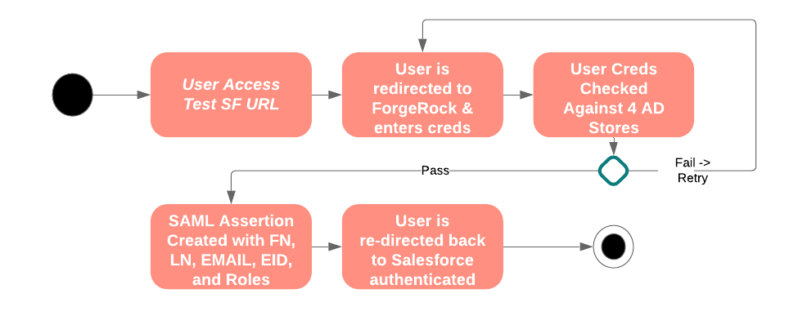

Description
- User access test Salesforce URL
- User is redirected to ForgeRock for authentication
- The user’s credentials are checked against the 4 AD Domains.
- If one of the Domains in Step 3 validates the users credentials proceed to Step 6
- If none of the Domains in Step 3 can validate the user’s credentials, fail login and return to Step 2 requesting users credentials with failed login message
- ForgeRock mints a new SAML assertion with the users First Name, Last Name, eMail, Enterprise ID and custom Roles for Salesforce only of the user (attributes are pulled from AD).
- User is redirected to the Salesforce and is now authenticated in Salesforce

Success Criteria
- Internal or External User can access Salesforce successfully.

Use Case 4. – OIDC (Salesforce) restricted Access by IP only

Prerequisite
- Install ForgeRock Access Manager 6.5.x
- Setup a test instance of Salesforce
- Configure Auth Tree for Salesforce as authentication provider
- Setup test app on Salesforce

Activity Diagram
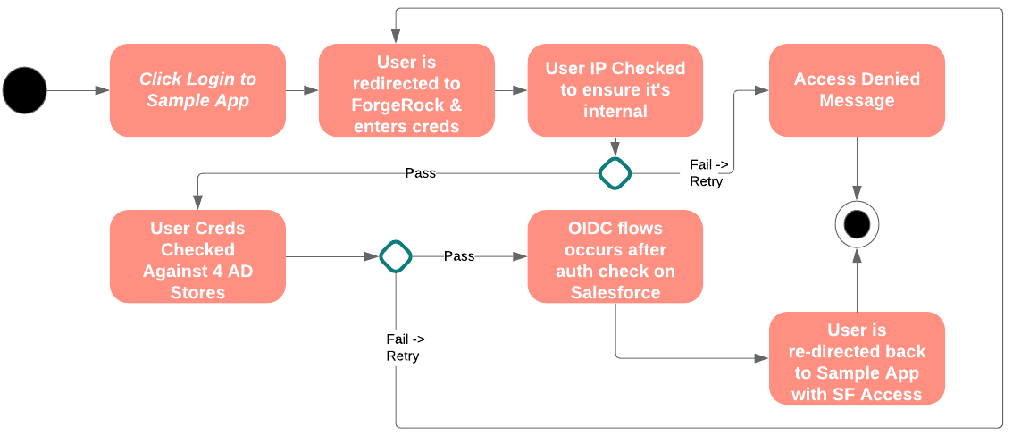

Description
- User access test Salesforce URL
- User is redirected to ForgeRock for authentication
- The user’s IP is checked to determine if internal or external.
- If the user’s IP is internal, the user proceeds to step 6.
- If the user’s IP is external, the user is redirected to access denied.
- The user’s credentials are checked against the 4 AD Domains.
- If one of the Domains in Step 6 validates the users credentials proceed to Step 9
- If none of the Domains in Step 6 can validate the user’s credentials, fail login and return to Step 2 requesting users credentials with failed login message
- ForgeRock redirects user to Salesforce with authorization permission.

Success Criteria
- Internal user can access Salesforce successfully while an external user is denied access.
- Custom OIDC Claim containing:
  - Login ID – sameaccountname
  - First name - Givenname
  - Last name - SN
  - Department - Department
  - Enterprise ID - EID
  - Roles - carlicense

Use Case 5. – Test CA PA migration to ForgeRock Web Agent

Prerequisite
- Install ForgeRock Access Manager 6.5.x
- Setup sample SPA that uses CA PA
- Configure Auth Tree for FR Web Agent

Activity Diagram
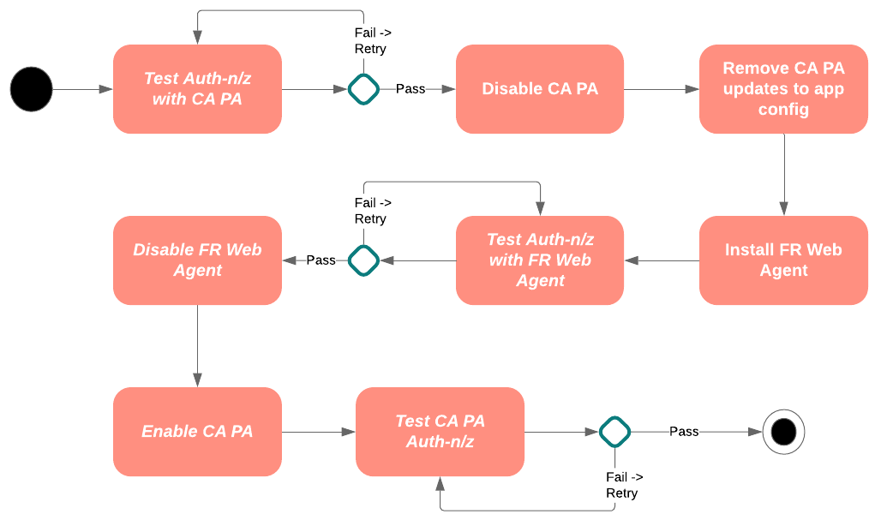

Description
- Test CA PA for proper Auth-n/z functionality
- Disable CA PA
- Remove/Restore Web App config back to standard
- Install ForgeRock Web Agent
- Test ForgeRock Web Agent Auth-n/z functionality
- Disable ForgeRock Web Agent
- Enable CA PA
- Test CA PA Auth-n/z

Success Criteria
- A system that is currently using CA PA as an enforcement point, can be changed to use ForgeRock Web Agent as an enforcement point. Proper Authentication and Authorization is capable before and after the migration from CA PA to ForgeRock Web Agent.

Use Case 6. – CA PA in front of CCA – to route through ForgeRock Identity Gateway

Prerequisite
- CA PA integrated with CCA WebApp (SPA)
- Install ForgeRock Access Manager 6.5.x
- Install ForgeRock Identity Gateway 6.5.x
- Create an IG route
- Sample syntax and script to generate an CA Cookie
- Test CCA WebApp

Activity Diagram
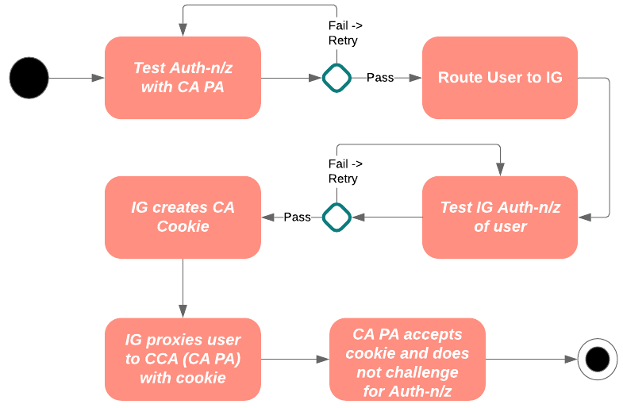

Description
- Test Auth-n/z with CA PA
- Route user through IG
- IG Authenticates the user
- IG creates a CA cookie and puts it on the users session
- IG Proxies user to CCA passing the CA cookie in the session
- CA PA accepts the cookie, and grants CCA WebApp access to the user

Success Criteria
- User can access CCA WebApp going through IG to CA PA. CA PA does not need to authenticate the user because the CA cookie already exists (created by IG).

Use Case 7. – Generic and Branded Login Screen Plus Duo MFA Integration

Prerequisite
- Install ForgeRock Access Manager 6.5.x
- Install ForgeRock Identity Gateway 6.5.x
- Internal and external IPs provided

Activity Diagram
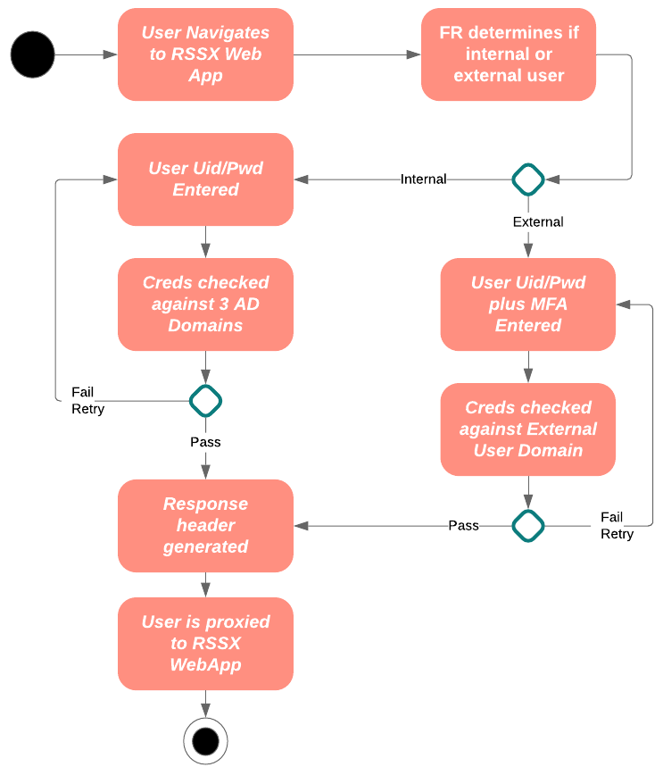

Description
- User navigates to RSSX WebApp
- ForgeRock determines if the user is internal or external
- If the user is internal, the uid/pwd of the user is collected
- If the user is external, the uid/pwd and Duo MFA of the user is collected
- Internal user is authenticated against 3 Domains
- External user is authenticated against external domain
- If the user fails authentication, the user is requested to retry
- If the user passes authentication the response header is generated with (all gathered from AD):
  - Login ID – sameaccountname
  - First name - Givenname
  - Last name - SN
  - Department - Department
  - Enterprise ID - EID
  - EMP Type (Best Buy, Walmart, etc.) - emptype
  - Roles - carlicense

Success Criteria
- Internal users see a branded Verizon login screen and can use their primary creds for a successful login.
- External users see a generic login screen and can use their Verizon creds for a successful login.

Use Case 8. – Impersonation

Prerequisite
- Install ForgeRock Access Manager 6.5.x
- Install ForgeRock Identity Gateway 6.5.x
- Validate SPA Integration
- Test ServiceNow environment (may not need if just email sent)

Activity Diagram
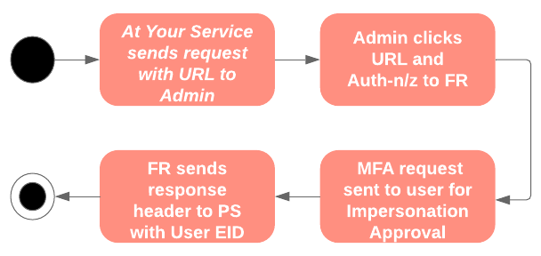

Description
- At Your Service sends an email request to SPA Admin. eMail contains URL with end user Enterprise ID.
- Admin is directed to ForgeRock and auth-n/z into ForgeRock
- ForgeRock sends MFA request to end user for impersonation approval
- ForgeRock sends response to PeopleSoft with end user EnterpriseID

Success Criteria
- Admin is able to successfully login to PeopleSoft as end user with approval from end user.
- Admin cannot login to any other application as end user.

Use Case 9. – Certificate Authentication

Prerequisite
- Install ForgeRock Access Manager 6.5.x
- Setup a test SPA
- Configure Auth Tree for SPA as SP

Activity Diagram
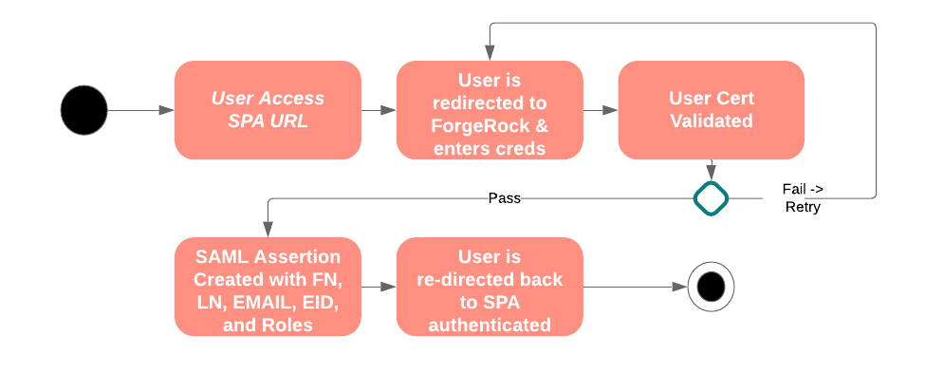

Description
- User access test SPA URL
- User is redirected to ForgeRock for authentication
- The user’s cert is validated.
- If users cert is valid, proceed to Step 6
- If the users cert is not valid, redirect to login screen for uid, pwd.
- ForgeRock mints a new SAML assertion with the users First Name, Last Name, eMail, Enterprise ID and Roles of the user.
- User is redirected to the Salesforce and is now authenticated in Salesforce

Success Criteria
Internal or External User can access Salesforce successfully.

Use Case 10. – IWA Authentication

Prerequisite
- Install ForgeRock Access Manager 6.5.x
- Setup a test instance of SPA
- Configure Auth Tree for SPA as SP
- Configure IWA for Kerb auth-n

Activity Diagram
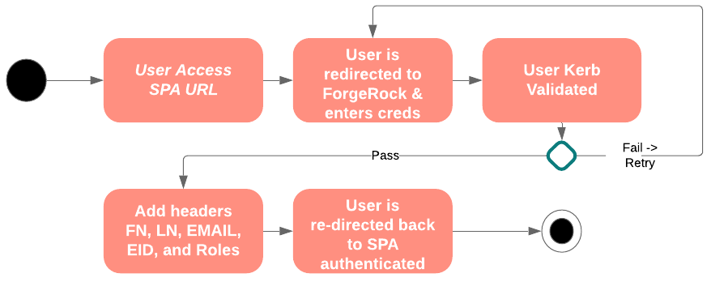

Description
- User access test SPA URL
- User is redirected to ForgeRock for authentication
- The user’s Kerb ticket is validated.
- If users cert is valid, proceed to Step 6
- If the users cert is not valid, redirect to login screen for uid, pwd.
- ForgeRock redirects to the SPA with the users First Name, Last Name, eMail, Enterprise ID and Roles of the user.
- User is redirected to the Salesforce and is now authenticated in Salesforce

Success Criteria
- Internal user on the domain can access the SPA without being challenged for credentials from Windows machine
- Internal user on the domain can access the SPA without being challenged for credentials from MAC
- Internal user on second domain can access the SPA without being challenged for credentials from MAC

Use Case 11. – External Federation (Multi-IdP) & ForgeRock to SiteMinder SSO

Prerequisite
- Install ForgeRock Access Manager 6.5.x
- Install ForgeRock Identity Gateway 6.5.x
- Validate PeopleSoft Integration with CA SiteMinder
- Setup Okta test IdP and Federate with ForgeRock passing Enterprise ID
- Create AuthTree to pass the SiteMinder session cookie to the CA PA.
- This app is used by Verizon, Verizon Media, Verizon Connect folks. So, we need a select IdP page as first page (or IP or User Agent to determine who they are).
- User Header, cookie and IP to determine if we know the user already and auto direct without making the user select. Otherwise, show IdP options to select.
- It’s recommended to use a SAML integration, otherwise SiteMinder customization will be needed

Activity Diagram
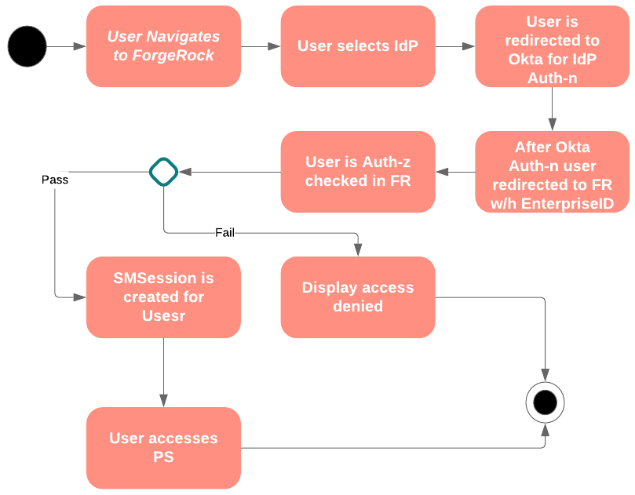

Description
- User navigates to ForgeRock for authentication
- User selects IdP
- User is redirected to Okta for authentication
- Okta mints a SAML assertion with Enterprise ID
- User is redirected back to FR
- User is Auth-z checked in FR
- New SiteMinder SMSession is created and user is directed to PeopleSoft
- User successfully accesses PS

Success Criteria
External user can successfully use Okta as an IdP to gain access to PeopleSoft.

Use Case 12. – SiteMinder to ForgeRock SSO

Prerequisite
- Install ForgeRock Access Manager 6.5.x
- Install ForgeRock Identity Gateway 6.5.x
- Validate SPA Integration with CA SiteMinder
- Create AuthTree to consume the SiteMinder session cookie for authentication purposes.

Activity Diagram
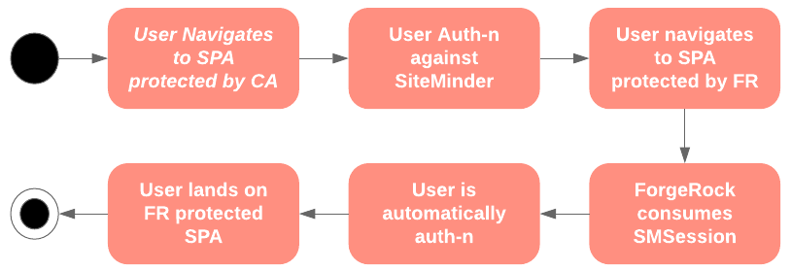

Description
- User navigates to SPA protected by CA
- User authenticates against CA SiteMinder
- User now navigates to SPA protected by ForgeRock
- ForgeRock consumes SMSession from SiteMinder as authentication token
- User is directed to ForgeRock protected SPA and info is displayed

Success Criteria
SiteMinder authenticated user can access a ForgeRock protected app without being challenged for authentication.

Use Case 13. – ForgeRock Identity Gateway & Web Agent Integration

Prerequisite
- Install ForgeRock Access Manager 6.5.x
- Install ForgeRock Identity Gateway 6.5.x
- Install ForgeRock Web Agent in front of SPA

Activity Diagram
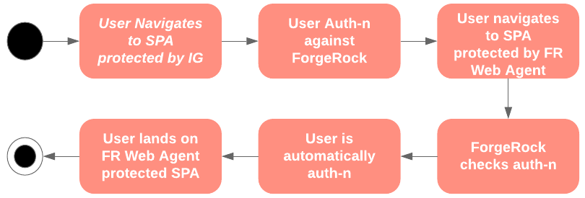

Description
- User navigates to SPA protected by the ForgeRock Identity Gateway
- User authenticates against ForgeRock
- User now navigates to SPA protected by ForgeRock Web Agent
- ForgeRock Web Agent checks if the user is already authenticated and allows user to pass
- User is directed to ForgeRock Web Agent protected SPA and info is displayed

Success Criteria
The integration (auth-n/z) between the ForgeRock Identity Gateway and the ForgeRock Web Agent is seamless.

Use Case 14. – Single Logout

Prerequisite
- Install ForgeRock Access Manager 6.5.x
- Install ForgeRock Identity Gateway 6.5.x
- SPA protected by ForgeRock.
- SPA protected by CA.
- SPA with single logout button

Activity Diagram
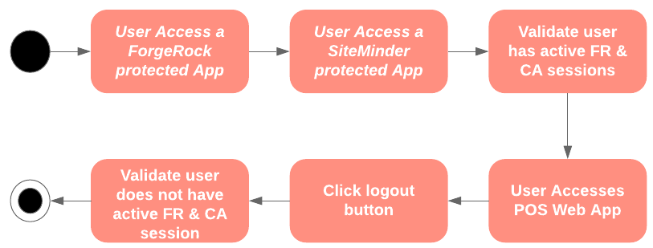

Description
- User navigates to SPA protected by ForgeRock to create a ForgeRock session
- User navigates to SPA protected by SiteMinder to create a SiteMinder session
- User now clicks the logout button on the SPA app
- User is logged out of both ForgeRock and SiteMinder

Success Criteria
- A user with both a ForgeRock and SiteMinder active session will be logged out of both applications when one logout button is clicked.

Use Case 15. – Internal Users never leaves Verizon Network for Auth-n/z

Prerequisite
- Install ForgeRock Access Manager 6.5.x internally & in DMZ
- Install ForgeRock Identity Gateway 6.5.x internally & in DMZ
- SPA protected by ForgeRock.
- SPA protected by CA.
- Internal:
  - vzw.corp.com
  - vzw.net.com
  - Verizon.com
- External
  - vzw.com
  - Verizon.com
  - Verizonwireless.com

Activity Diagram
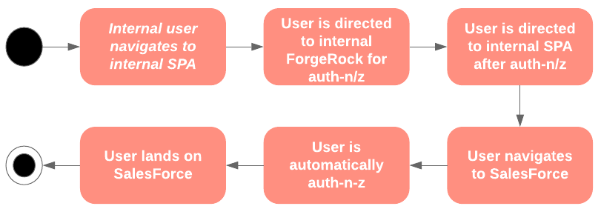

Description
- User navigates to internal SPA protected by ForgeRock
- User is redirected to Internal ForgeRock for auth-n/z
- User is redirected to back to internal SPA now authenticated
- User navigates to Salesforce
- User is redirected to ForgeRock in Verizon DMZ for auth-n/z
- SAML assertion is minted without challenging the user for auth-n/z
- User lands on the Salesforce home page

Success Criteria
- An internal Verizon user (on the Verizon intranet) does not have to leave the Verizon intranet to auth-n/z for internal ForgeRock protected applications.
- An internal Verizon user (on the Verizon intranet) that has already auth-n/z to internal ForgeRock, does not need to auth-n/z when navigating to a external (cloud) app, such as Salesforce.

Use Case 16. – Multiple Authentication

Prerequisite
- Install ForgeRock Access Manager 6.5.x
- Install ForgeRock Identity Gateway 6.5.x
- SPA protected by ForgeRock.
- Auth tree that uses IWA, Certificate and Duo for authentication

Activity Diagram
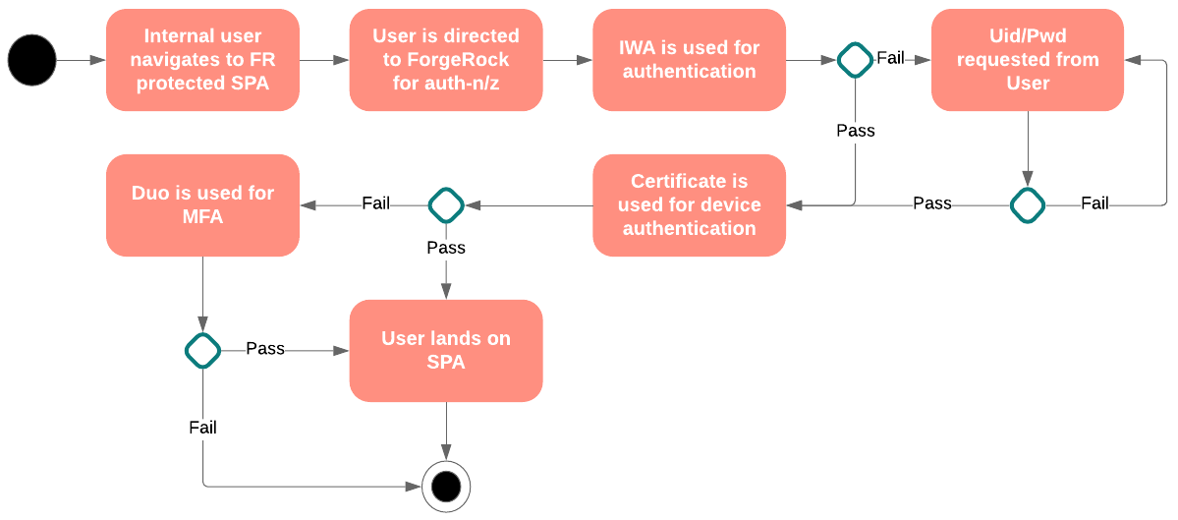

Description
- User navigates to ForgeRock protected SPA
- User is redirected to ForgeRock for auth-n/z
- User authenticates against ForgeRock via IWA
- ForgeRock checks the device certificate
- If the user is on a device with a valid certificate, proceed to step 8
- If the user is not on a device with a valid certificate, proceed to step 7
- User is required to 2FA via Duo. If user passes 2FA, proceed to step 8
- User is directed to SPA

Success Criteria
- User is required to go through IWA, and certificate authentication before being able to access the SPA.
- If a user fails IWA authentication, the user is required to enter a uid/pwd for primary authentication and still needs to pass certificate authentication.
- If the user cannot pass certificate authentication, then Duo 2FA is required.

Use Case 17. – Use LDS (Virtual Directory) for Auth-n/z

Prerequisite
- Install ForgeRock Access Manager 6.5.x
- Install ForgeRock Identity Gateway 6.5.x
- SPA protected by ForgeRock.
- Auth tree that uses LDS for authentication
- LDS (Virtual Directory) available with Service Account creds

Activity Diagram
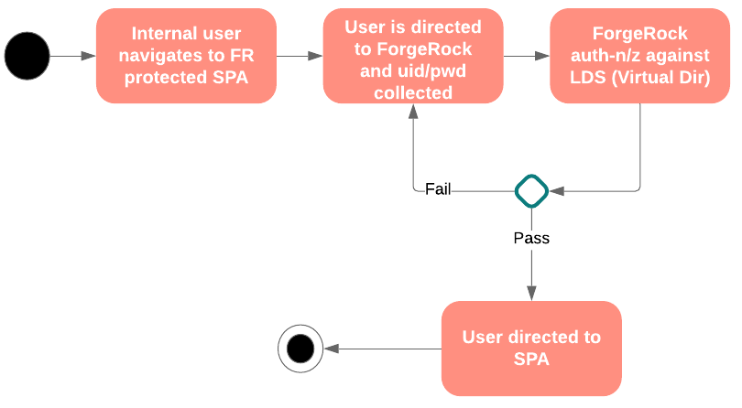

Description
- User navigates to ForgeRock protected SPA
- User is redirected to ForgeRock for auth-n/z and uid/pwd is collected
- User authenticates against ForgeRock via LDS
- If the user passes authentication, proceed to step 6
- If the user fails authentication, proceed to step 2
- User is directed to SPA

Success Criteria
- ForgeRock is able to use a Virtual Directory for primary (uid/pwd) authentication successfully.

